Pyhula Software Quick Reference Guide

|  |  |  |  |
| --- | --- | --- | --- |
| **Version** | **Date** | **Description** | **Author** |
| 1.1.0 | 2024-08-08 | Initial commit | LFH, |
|  |  |  |  |

# 1 OVERVIEW

Pyhula software is used to connect and control planes in real-time, also used to make drone formation by programs. This document provides the installation of pyhula and a quick guide to use this software.

browser. It contains “userapi module”, update statement and so on. All the functions of userapi module are displayed there with detail comments.

**Warnning: The critical statements in 6th section should be keep in mind everytime controlling planes!**

# 2 INSTALLING SOFWARES

## 1. Supported Operating Systems

- windows 7 (x86/x86\_64)

- windows 10 (x86/x86\_64)

## 2. Python installer

Python installers are in the dist folder. The one named with “amd64” is applied for x86\_64 system, the other is for x86 system.

In the official python website: <https://www.python.org/downloads/windows/> , same installers are supplied for downloading.

Warning: only python 3.6 is supported so far.

## 3. Installing Python and Configure

A. Double click the python installer. A dialogue window as below figure will pop up. Select “Add Python 3.6 to PATH”, and then choose “Customize installation”.

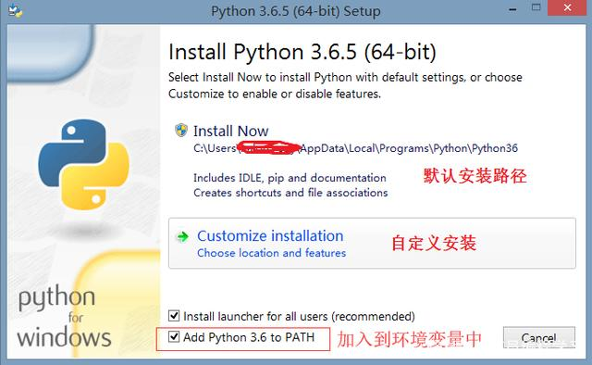

B. The next dialogue is as the below figure. Select all the opetions and click the “Next” button.

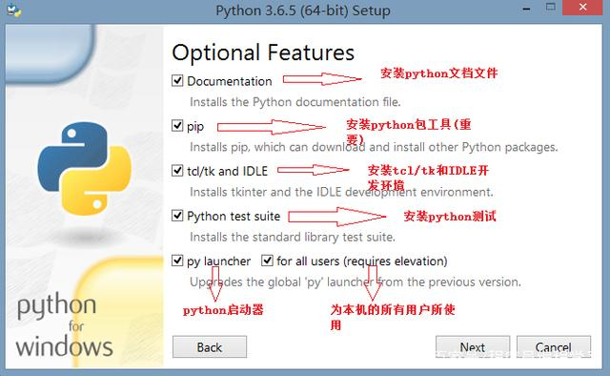

C. Select the 4 options as the below picture, and “Browse” to the target path. Than click the “Install” button.

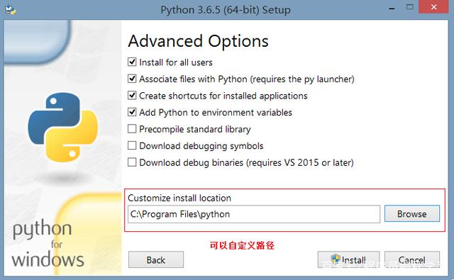

D. This picture shows status of installing.

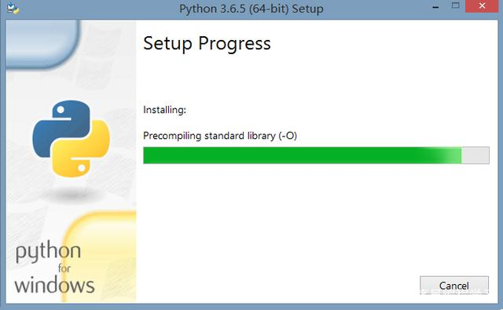

E. The below picture means setup is finished.

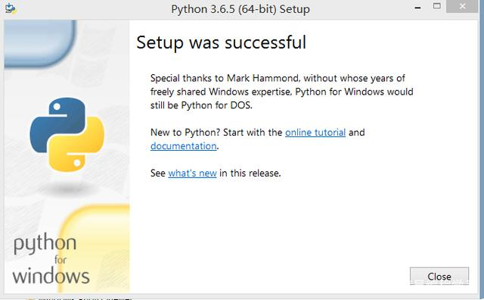

F. Check python version. Click on Start, and input “cmd” in the search bar. Then right click the cmd.exe, and click on “Run as Administrator”. After the cmd window poped， type in **python –V** as shown below, and enter. Python version will be printed on the screen. If the version is same as the installation’s, start to install pyhula .

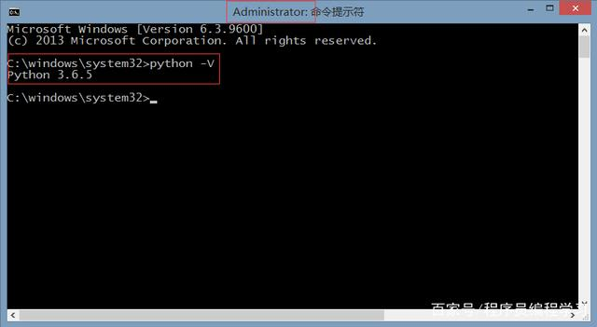

## 4. Installing pyhula

A. Check python’s “pip” command. Open cmd as upper description and type in **pip --version**. If the returned result is like the below picture, go to the next step.

C:\Users\ADMINI~1\AppData\Local\Temp\企业微信截图_15682927261464.png

B. Install whl.

Open the cmd and type in:

**pip install pyhula**

If you can’t connect to the Internet, open the cmd, direct to the path of whl, and type in command to install pyhula.

For x86\_64 system:

**pip install pyhula-1.1.0-cp36-cp36m-win\_amd64.whl**(Please replace this file when installing other versions.)

C. Check the whl’s installation. In the cmd, type in **pip list** and enter. If there are two strings like the below picture, the whl installation is finished.

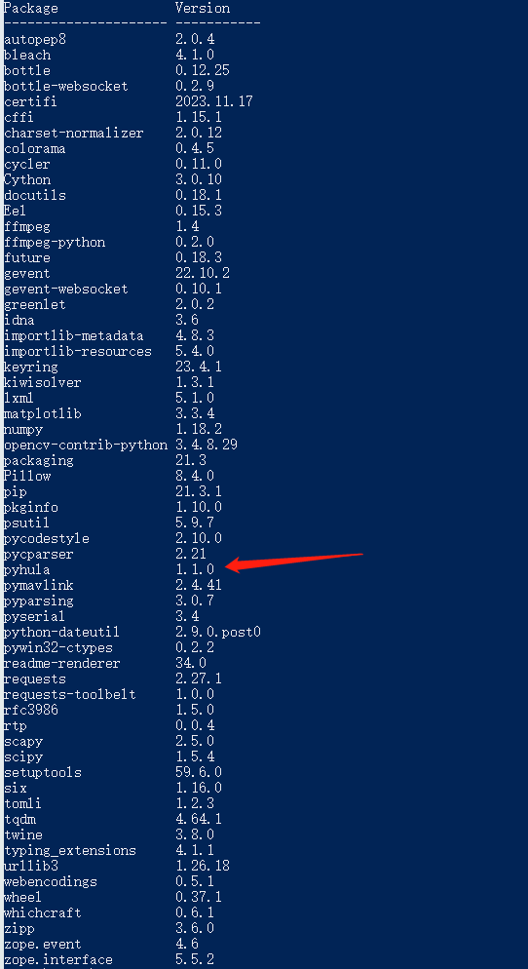

# 3 Updating

## updating pyhula

Open the cmd and type in **pip install --upgrade pyhula** .